1)

A)

Given A[0….n]

$root=A_{0}$

$level 1=A_{1}……A_{1+d}$

$level k=A_{d^{k+1}-d^{k}-1}……A_{d^{k+1}-d^{k}-1+\left(\sum_{i=1}^{k}{i}\right)-1}$

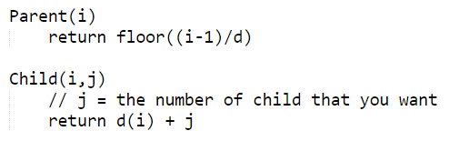

B) $h=\log_{d}\left(n\right)$

C) Extract-Max procedure for the D-ary heap is exactly the same as the procedure to extract the max for the binary heap.

The only time when d-ary heap differs from the binary heap is during the Max-Heapify process. Just as with the binary heap, we let the new root “float” down to its natural place in the heap. In the worst case possible, the new root might need to float all the way down to the bottom of the tree and it must traverse all the children of every level along the way. This means that the Max-Heapify procedure would take $O\left(dlog_{d}\left(n\right)\right)$

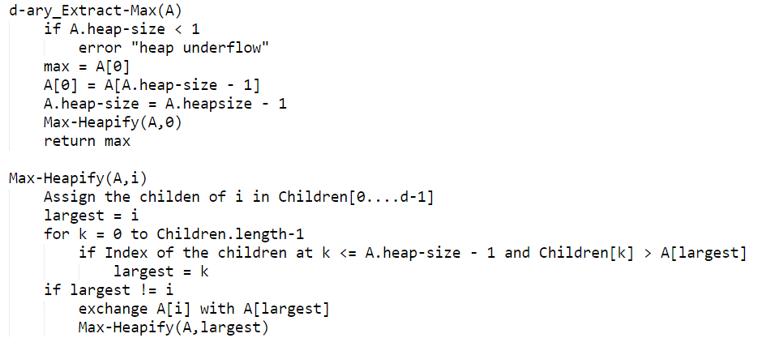

D & E)

The Insert and Increase-Key procedures for the d-ary heap is the same as The Insert and Increase-Key procedure for the binary heap; therefore, the run time is $O(\log_{d}{n) }$

